Brian Cullinan

Project 1: Easy-Paint

3/5/09

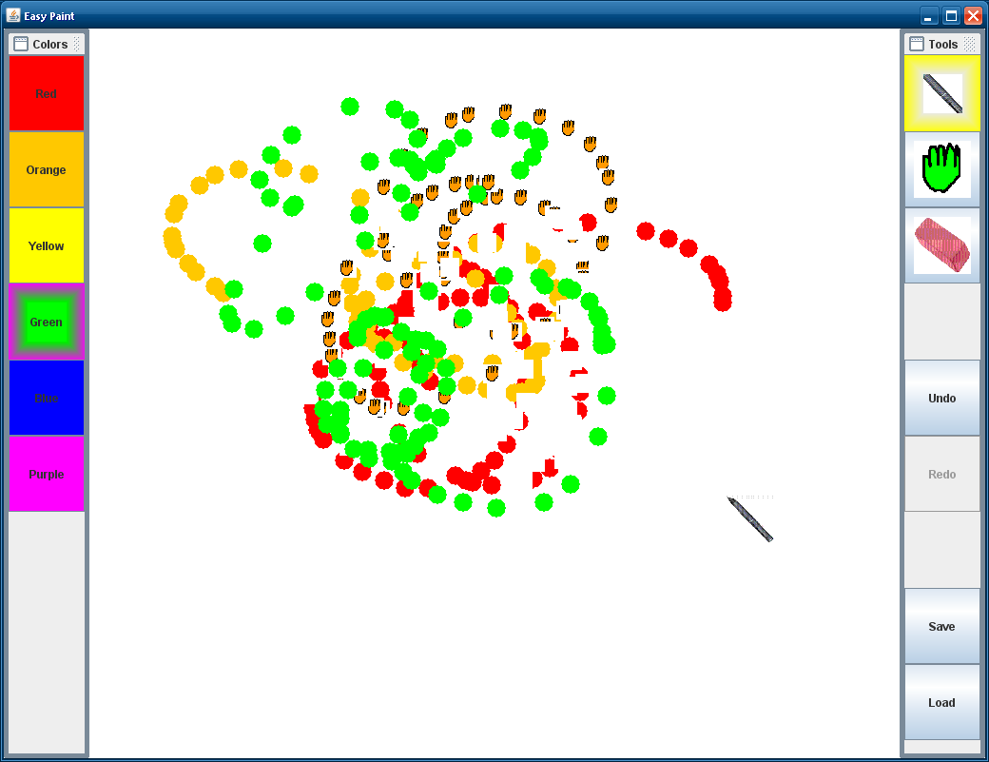

Problem:

The objective of this assignment is to entertain young children with a finger painting device. It should be deployable on a variety of systems, and capture the attention of children. The child should be able to use the device to create artistic images in a similar fashion as finger painting but without the mess of paint.

|  |  |  |
| --- | --- | --- |
| Presentation/Docs. | 100% | Source code included in e-mail |
| Level 1: Bare Basics | 80% | Opens JDesktopPane for drawing. Has painting tools on the right.  Doesn’t not include useless sliders that are too small for a child to use anyways.  Supports saving and loading |
| Level 2: Ready for Kid Testing | 100% | Has additional components like Images, and combo boxes and JDialogs.  Has lots of colors and uses images to illustrate what tool is being used.  Has erase and undo functionality  Has on screen keyboard for typing in file names |
| Level 3: Fancy extras | 80% | Customized controls that draw highlights and pictures on the selected button.  Custom JDialog that is used for saving and loading.  Has a fading effect to show selected button |
| Interface quality | 100% | Big buttons in interface for imprecise clicking |

Overall Design:

My main priority for this assignment was not only to visually and aesthetically appeal to children but also be function in different environments. The buttons for controlling the active tool and color are large because children have imprecise finger pointing skills. They are colorful and flashy to encourage them to experiment and learn with different tools. It is meant to work with a touch screen, but it will also work with a mouse. The painting area is easy to figure out because of the picture watermark, indicating that it can be painted on. To paint, all that is needed is a click. This makes a mark on the page, and optionally the painter can drag to create more complex shapes. The load and save buttons are easy to navigate and use as well.

User Profile:

This tool is geared towards any child between the ages of 3 and 10. This wide range of ages implies a few things. The complexity of the program for example; more painting options should be available to older children. Therefore the brush size and color picker can be used. When deployed on a touch screen this program is still amusing to older children just from the nature of the pointing interface. Older children would possibly be away of the tooltip feature, or at least be able to figure it out; therefore key options have been made more discrete to younger children. Some textual instructions are shown in the main interface, for older children who know how to read, to provide a key to using some of the more advanced features. Because the target user is also a very young child not every feature can be displayed on the main screen. For this reason only simple painting controls are shown is a very easy to navigate fashion. The color toolbar on the left shows the primary and secondary colors. The selected color is highlighted. The toolbar on the right shows the main controls; small paint brush, large paint brush, eraser, and the undo button. Then the redo and save and load buttons are shown a little lower on the right toolbar; this is done so that those buttons are distracting to small children. Any child in the range of ages should be able to learn how to use these tools. Buttons have pictures to illustrate their functionality. Children between the ages of 5 and 10 should be able to figure it out though.